Hendrik Melse

This document outlines the test procedures for the batteries and contains the results

Battery Testing

Battery Test Procedures and Results

Revision: 1.0.0



Table of Contents

1 Introduction 2

1.1 Scope 2

2 Acronyms and Definitions 2

3 Physical and Electrochemical Characteristics Test 2

3.1 Basic Cell Information 2

3.2 Visual Inspection 2

3.3 Physical Properties 2

3.4 Electrochemical Characteristics 2

4 Charge Cycling 2

5 Cell Over-charge 2

6 Cell Over-discharge 2

7 External Short Protection 2

8 Circuit Schematic 2

9 Vibration Test 2

10 Vacuum Test 2

# Introduction

This document describes the test procedures for the Lithium-Ion cells to be flown on CougSat-1.

Select 8 new batteries to perform tests on. Label each battery before performing any tests. The date shall be recorded for each test performed. Make not of any unusual or unexpected behavior. Take and include photo documentation of all testing activities.

# Acronyms and Definitions

# Physical and Electrochemical Characteristics Test

## Basic Cell Information

**Date:**

Record the following information:

* Manufacturer:
* Cell model number:
* Date of manufacture:
* Manufacturer cell/battery specifications:
  + Maximum/minimum voltage:
  + Temperature range:
* Cell chemistry:
* Electrolyte type:

## Visual Inspection

**Date:**

### Instructions

Inspect cells for any deformations such as scrapes, bulges, or dents. If possible remove the cell wrappings prior to performing the inspection.

### Results

|  |  |
| --- | --- |
| Cell | Notes |
| BT1 |  |
| BT2 |  |
| BT3 |  |
| BT4 |  |
| BT5 |  |
| BT6 |  |
| BT7 |  |
| BT8 |  |

### Photos

Attach photograph(s) here

## Physical Properties

**Date:**

### Instructions

Measure the length, width, height, and mass of each cell, to 0.1mm or 0.1g precision. Length, width, and height are defined as follows:

Length: Horizontal length of the battery with the serial number upright

Width: Vertical length of the battery with the serial number upright

Height: The smallest dimension

### Results

|  |  |  |  |  |
| --- | --- | --- | --- | --- |
| Cell | Length | Width | Height | Mass |
| BT1 |  |  |  |  |
| BT2 |  |  |  |  |
| BT3 |  |  |  |  |
| BT4 |  |  |  |  |
| BT5 |  |  |  |  |
| BT6 |  |  |  |  |
| BT7 |  |  |  |  |
| BT8 |  |  |  |  |

### Photos

Attach photograph(s) here

## Electrochemical Characteristics

### Open Circuit Voltage

**Date:**

#### Instructions

Charge each cell to $4.1V$ and allow the cells to rest for 10 minutes before executing this test. Use the DMM to measure the voltage of each cell. Record voltage with $0.1V$ precision.

#### Results

|  |  |
| --- | --- |
| Cell | Open Circuit Voltage |
| BT1 |  |
| BT2 |  |
| BT3 |  |
| BT4 |  |
| BT5 |  |
| BT6 |  |
| BT7 |  |
| BT8 |  |

#### Photos

Attach photograph(s) here

### Closed Circuit Voltage

#### Instructions

Use the same cells from the open circuit voltage test above. In turn, discharge each cell at $1600mA$. Wait for 30 seconds and measure the voltage while discharging. Record voltage with $0.1V$ precision.

#### Results

|  |  |
| --- | --- |
| Cell | Open Circuit Voltage |
| BT1 |  |
| BT2 |  |
| BT3 |  |
| BT4 |  |
| BT5 |  |
| BT6 |  |
| BT7 |  |
| BT8 |  |

#### Photos

Attach photograph(s) here

### Open Circuit 14-Day

#### Instructions

Discharge each cell to $2.5V$ at constant voltage. Cut off discharging once current tapers below $32mA$. Record the Open Circuit Voltage (OCV) at discharge termination. Let the cells rest for 14 days, check the OCV for each cell on days 1, 3, 7, 10, and 14.

Reject any cells with declining voltages $>2.0mV$.

#### Results

|  |  |  |  |  |  |  |  |
| --- | --- | --- | --- | --- | --- | --- | --- |
| Cell | Discharge  Termination | Day 1 | Day 3 | Day 7 | Day 10 | Day 14 | Decline |
| BT1 |  |  |  |  |  |  |  |
| BT2 |  |  |  |  |  |  |  |
| BT3 |  |  |  |  |  |  |  |
| BT4 |  |  |  |  |  |  |  |
| BT5 |  |  |  |  |  |  |  |
| BT6 |  |  |  |  |  |  |  |
| BT7 |  |  |  |  |  |  |  |
| BT8 |  |  |  |  |  |  |  |

#### Photos

Attach photograph(s) here

# Charge Cycling

## Instructions

Charge and discharge the batteries in the following order:

* Charge
* Discharge
* Charge
* Discharge
* Charge

During charging, record voltage, current, and temperature at 10-minute intervals. Charge at constant current of $C/2$ ($1600mA$) until the batteries reach $4.2V$, then charge at constant voltage until current drops below $50mA$.

During discharging, record voltage, current, and temperature at 10-minute intervals. Discharge at a rate of $C/2$ ($1600mA$) until the batteries reach $2.5V$. Record the capacity.

Record values in a spreadsheet, attach a plot for each cell below.

## Results

|  |  |  |
| --- | --- | --- |
| Cell | Discharge 1 Capacity | Discharge 2 Capacity |
| BT1 |  |  |
| BT2 |  |  |
| BT3 |  |  |
| BT4 |  |  |
| BT5 |  |  |
| BT6 |  |  |
| BT7 |  |  |
| BT8 |  |  |

Include plots for voltage, current, and temperature here.

## Photos

Attach photograph(s) here

# Cell Over-charge

## Instructions

This procedure is designed to test the protection circuitry only, not the cells themselves. Perform this test on non-flight cells only.

Charge the cells at $3200mA$/cell. Record the voltage at which the protection circuitry opens.

Discharge the cells at a rate of $640mA$/cell and record the voltage at which the protection circuit resets.

## Results

|  |  |
| --- | --- |
| Protection Circuit Opens | Protection Circuit Resets |
|  |  |

## Photos

Attach photograph(s) here

# Cell Over-discharge

## Battery Capacity Test

### Instructions

This test is designed to test the protection circuitry only, not the flight cells, Perform this test on non-flight cells only.

Use the programmable load to measure the battery capacity before and after the protection circuitry test. The battery capacity after the over-discharge test should be within $5\%$ of the capacity before the over-discharge test.

### Results

|  |  |  |  |
| --- | --- | --- | --- |
| Battery | Pre-test Capacity | Post-test Capacity | Percent Change |
| A |  |  |  |
| B |  |  |  |

### Photos

Attach photograph(s) here

## Circuit Test

### Instructions

This procedure is designed to test the protection circuitry only, not the flight cells. Perform this test on non-flight cells only.

Connect two cells to the EPS and. Discharge the battery at $3200mA$/cell until the protection circuit opens, record the voltage at which this happens.

Using the same cell, charge the cell at $640mA$/cell and record the voltage at which the protection circuit resets.

### Results

|  |  |
| --- | --- |
| Protection Circuit Opens | Protection Circuit Resets |
|  |  |

### Photos

Attach photograph(s) here

# External Short Protection

## Battery Capacity Test

### Instructions

This test is designed to test the protection circuitry only, not the flight cells, Perform this test on non-flight cells only.

Use the programmable load to measure the battery capacity before and after the short protection test. The battery capacity after the short protection test should be within $5\%$ of the capacity before the short protection test.

### Results

|  |  |  |  |
| --- | --- | --- | --- |
| Battery | Pre-test Capacity | Post-test Capacity | Percent Change |
| A |  |  |  |
| B |  |  |  |

### Photos

Attach photograph(s) here

## Circuit Test

### Instructions

This procedure is designed to test the protection circuitry only, not the flight cells. Perform this test on non-flight cells.

Connect two cells to the EPS and apply a short. Capture the protection activation event using an oscilloscope. Verify that the protection circuitry opens within 1 $00ms$ of the short being applied.

### Results

|  |  |
| --- | --- |
| Protection Circuitry Activation Event | Response Time |
|  |  |

### Photos

Attach photograph(s) here

# Circuit Schematic

Below is the cell protection schematic, one per battery cell. U26 is the cell protection IC which monitors the voltage between pins 5 and 6 and the current through the battery via the voltage drop over Q2 and R3. If it determines an error during discharging, the discharge direction FET is switched off (charging remains connected via the discharge FET’s body diode). If it determines an error during charging, the charge direction FET is switched off. Also below is the list of parameters it monitors.

|  |  |  |
| --- | --- | --- |
| Parameter | Disables | Threshold |
| Over-voltage | Charging | $$4.275V$$ |
| Under-voltage | Discharging | $$2.800V$$ |
| Over current charge | Charging | $$4.4A$$ |
| Over current discharge | Discharging | $$4.4A$$ |
| Short circuit discharge | Discharging | $$22A$$ |

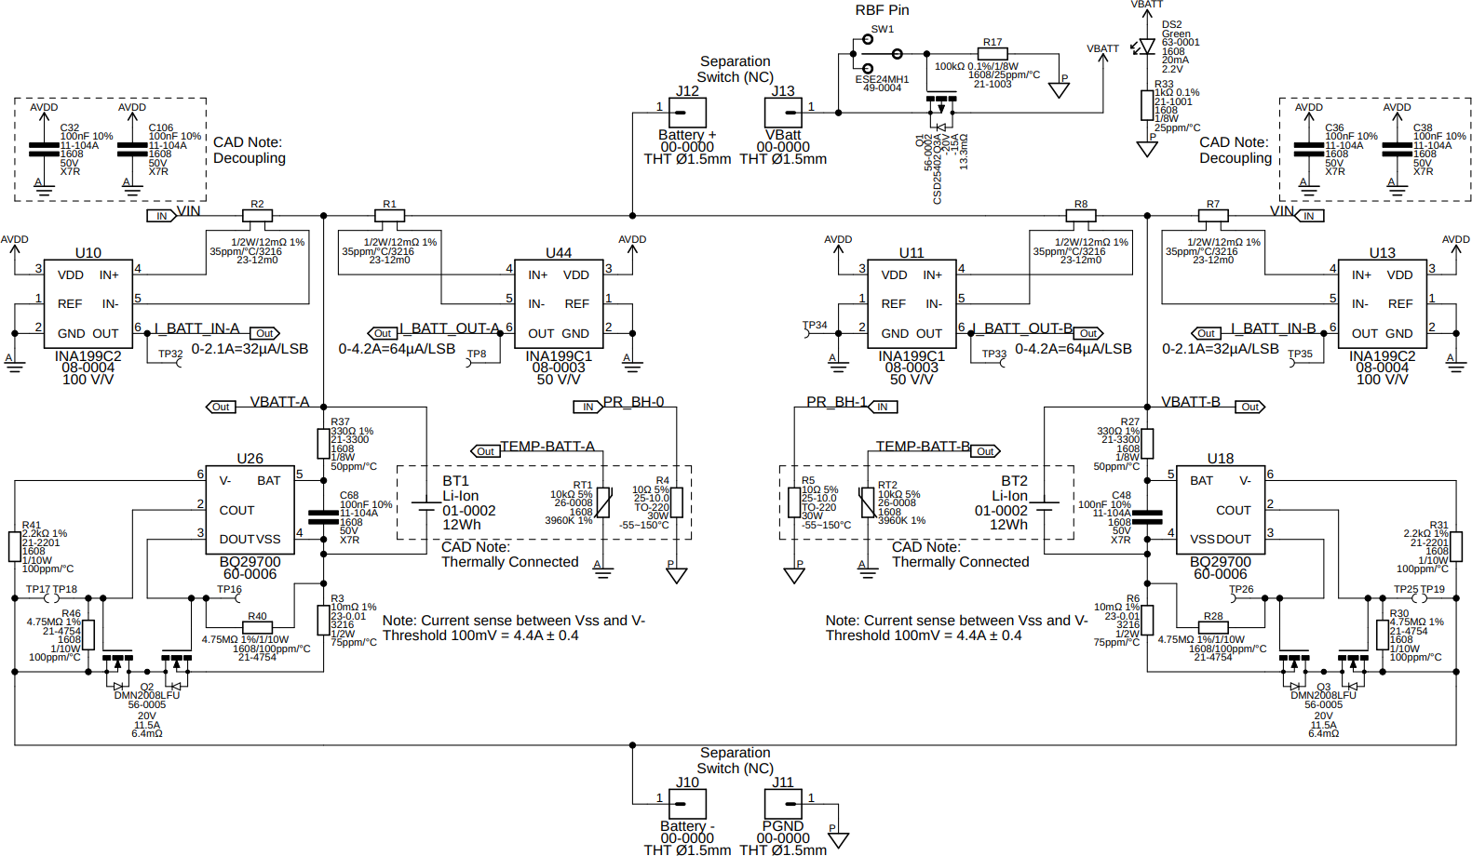

# Vibration Test

# Vacuum Test

## Pre-Vacuum Measurements

### Instructions

Charge cells to $4.1V$ before executing this test. Measure the length, width, height, and mass of each cell in the same manner as in section 3.3 above immediately before beginning this test. Also measure and record the voltage of each cell.

### Results

|  |  |  |  |  |  |
| --- | --- | --- | --- | --- | --- |
| Cell | Length | Width | Height | Mass | Voltage |
| BT1 |  |  |  |  |  |
| BT2 |  |  |  |  |  |
| BT3 |  |  |  |  |  |
| BT4 |  |  |  |  |  |
| BT5 |  |  |  |  |  |
| BT6 |  |  |  |  |  |
| BT7 |  |  |  |  |  |
| BT8 |  |  |  |  |  |

### Photos

Attach photograph(s) here

## Vacuum Test

### Instructions

Place the fully charged cells in the vacuum chamber and pull a vacuum at approximately $8 psi/minute$. Maintain a vacuum of about $0.1 psi$ for 6 hours. Record anything unusual or unexpected during this time.

### Results

Record any relevant observations here.

### Photos

Attach photograph(s) here

## Post-Vacuum Measurements

### Instructions

Measure the length, width, height, mass, and voltage of each cell post-vacuum. No measurement should have more than a $0.1\%$ deviation from the pre-vacuum measurement.

Complete the charge/discharge cycle specified in section 4. Measure and record the battery capacity. There should be less than $5\%$ change from the pre-vacuum measurement.

### Results

|  |  |  |  |  |  |
| --- | --- | --- | --- | --- | --- |
| Cell | Length | Width | Height | Mass | Voltage |
| BT1 |  |  |  |  |  |
| BT2 |  |  |  |  |  |
| BT3 |  |  |  |  |  |
| BT4 |  |  |  |  |  |
| BT5 |  |  |  |  |  |
| BT6 |  |  |  |  |  |
| BT7 |  |  |  |  |  |
| BT8 |  |  |  |  |  |

|  |  |
| --- | --- |
| Cell | Capacity |
| BT1 |  |
| BT2 |  |
| BT3 |  |
| BT4 |  |
| BT5 |  |
| BT6 |  |
| BT7 |  |
| BT8 |  |

### Photos

Attach photograph(s) here